2024 | Brush Run Outreach
 | Alzheimer’s Association  2835 E Carson St Suite 200 Pittsburgh, PA 15203
 | Beaver County Heart Association  3582 Brodhead Rd #201 Monaca, PA 15061
 | Beaver Falls High School Christmas Drive  1701 8th Ave. Beaver Falls, PA 15010
 | Blessed Bag  122 Muirfield Place Beaver, PA 15009
 | The Center  754 Ohio Ave. Midland, PA 15059
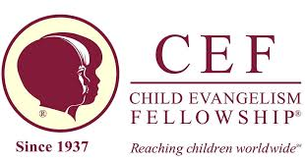 | Child Evangelism Fellowship of Beaver County  516 Smith Ferry Road Midland, PA 15059
 | City Rescue Mission  138 E Jefferson St #1/2 Butler, PA 16001
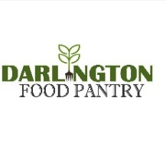 | Darlington Food Pantry  3385 Old Darlington Rd. Darlington, PA 16115
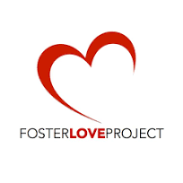 | Foster Love Project  463 S Trenton Ave Pittsburgh, PA 15221
 | Communicycle  714 Midland Ave. Midland, PA 15059
 | Relay For Life  Box 862. Carnegie, PA 15106
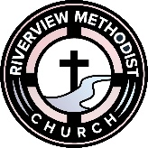 | Riverview Methodist Church Christmas Toy Drive  1099 Darlington Rd. Beaver Falls, PA
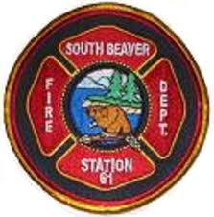 | South Beaver Fire Dept.  740 PA-168 Darlington, PA 16115
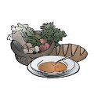 | Twelve Loaves Soup Kitchen  1031 2nd Ave. New Brighton, PA 15066
 | West Allegheny Global Methodist Church  1636 Graham Road Reynoldsburg, OH 43068
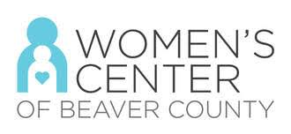 | Women’s Center of Beaver County  190 3rd St. Beaver, PA 15009
 | Yellow Ribbon Girls  600 Lawrence Ave. Ellwood City, PA 16117
 | Future Suggestions:
 | Brenda Kaiser’s Mission Trip
 | John Axtell’s Stairlift Ministry

